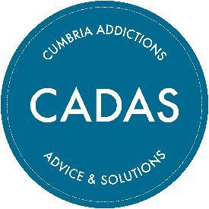

CADAS Recovery Coach

Thank you for your interest in the above position. This document contains some information you will find useful regarding CADAS and the role.

About us:
Cumbria Addictions: Advice and Solutions – or CADAS – is a registered charity and has been providing support, training and intervention to education, health and social care professionals, young people and their families for over 40 years.
We provide a recovery support service to individuals struggling with addiction and help families affected by problematic addictions. We support communities, professionals and employers with training and information provision.
We believe that our major strengths are our independence, our commitment to people and communities, our inclusive approach and our accessibility.
Our centres are located in Barrow, Carlisle, Kendal and Workington and since the pandemic we have been able to also offer a telephone helpline 5 days per week as well as offer telephone and video call support. This enables us to support a wide range of vulnerable clients throughout our large and mostly rural county.
To find out more about us go to www.cadas.co.uk or find us on Facebook or Twitter.
Our commitment to working with volunteers:
CADAS was founded by a group of community volunteers (as well as local professionals) and we see our approach as Asset Based Community Development (ABCD). We believe in working with and for the community and as such volunteers have an integral role in the running of our organisation, and delivery of our services.
Our volunteers work across the whole organisation and we have regular vacancies for office support, cleaners, marketing volunteers and many other roles throughout the county. People come to us for our client-facing volunteering opportunities and we support people to become helpline workers, recovery coaches and even health and wellbeing activity workers.
We currently have around 50 volunteers countywide supporting our small team of permanent staff.

About the role:
This is an exciting time for CADAS in Kendal the South Lakes as we develop and grow our services. The Recovery Coach role plays a crucial part in supporting the most vulnerable people in the community on their recovery journey and most importantly making a positive difference to people’s lives.

The Recovery Coach will work as part of a team, managing a caseload and supporting clients with problematic substance use or addictions and co-occurring serious mental illness. Support will be provided through assessment plans and one-to-one support, from referral through to sustained recovery and after-care. Over the last few years, we have developed our service offer to include digital support, therefore our clients can access their recovery sessions either through face-to-face at a centre, over the telephone or via video calls, meaning you could be helping people in your locality or from across the county.

Another element of the role is our Peer Support Group sessions, and you would be responsible for establishing, developing and delivering groups to clients who are struggling with problematic addictive behaviours, providing a safe environment to support sustained recovery, promote engagement, encourage self-esteem, well-being, self-responsibility and enhanced motivation.

The role will involve working positively with a wide range of organisations and groups to support our clients and good knowledge and understanding about safeguarding.
Location:
The Recovery Coach role will be based at the Kendal Office, primarily providing a service to clients in South Lakes Cumbria and through our digital inclusive approach supporting clients across the county.
Pay and benefits:
This role is either 30 or 37.5 hours per week. We offer £12.35 per hour for this role (this equates to £24,082.50 for a 37.5 hours full time equivalent), with a 6% pension contribution after the first 6 months.
We have a generous holiday package offering 36 days per year (pro rata) and cover the cost of eye tests, plus other perks.
Travel expenses are paid at 45p per mile from your official office base which would be agreed as part of your contract.
We aim to have a very flexible approach to working hours and base to help people manage other commitments so please talk to us about any suggestions you have.

Next steps…
Please review the Job Description and Person Specification that can be found alongside this document on our website and complete the application form highlighting how you meet our essential and desirable criteria. To access these documents, visit www.cadas.co.uk scroll to the bottom of any page (please see screen shot below) click recruitment and current vacancies – download the application form & the E&D form and email to the named person at the bottom of the application form.
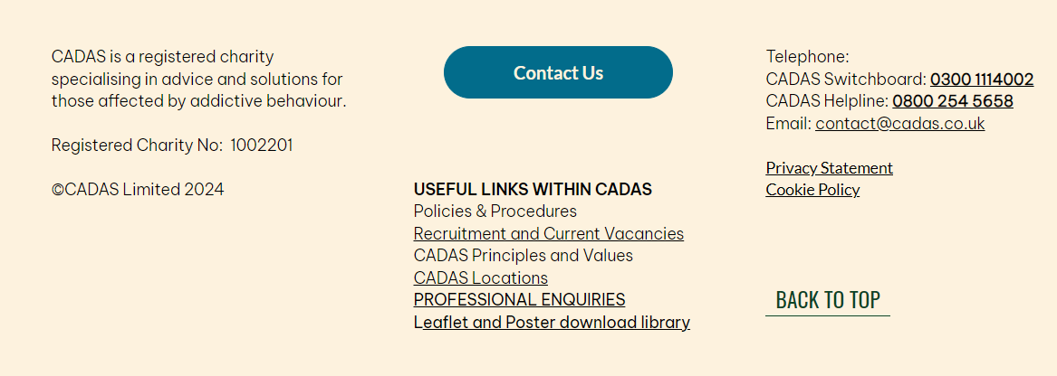
If you would like to discuss any details about the post, you can email Gail Jenson on gailj@cadas.co.uk
Applications should be returned via email contact shown on the bottom of the application form by 5.00pm Friday 1st August 2025.
The shortlisting and interview process:
Successful applicants will be invited to an interview at one of our offices – date to be confirmed.
If you are interested in the post and feel you have the skills but would like to discuss it, please get in touch with Gail Jenson on either gailj@cadas.co.uk or call on 07493 865637.

