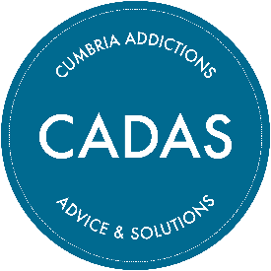

Cumberland Volunteer Coordinator (Information about role)

Thank you for your interest in the above position. This document contains some information you will find useful regarding CADAS and the role.

About us:
Cumbria Addictions: Advice and Solutions – or CADAS – is a registered charity and has been providing support, training and intervention to education, health and social care professionals, young people and their families for over 40 years.
We provide a recovery support service to individuals struggling with addiction and help families affected by problematic addictions. We support communities, professionals and employers with training and information provision.
We believe that our major strengths are our independence, our commitment to people and communities, our inclusive approach and our accessibility.
Our centres are located in Barrow, Carlisle, Kendal and Workington and since the pandemic we have been able to also offer a telephone helpline 5 days per week as well as offer telephone and video call support. This enables us to support a wide range of vulnerable clients throughout our large and mostly rural county.
To find out more about us go to www.cadas.co.uk or find us on Facebook or Twitter.
Our commitment to working with volunteers:
CADAS was founded by a group of community volunteers (as well as local professionals) and we see our approach as Asset Based Community Development (ABCD). We believe in working with and for the community and as such volunteers have an integral role in the running of our organisation, and delivery of our services.
Our volunteers work across the whole organisation and we have regular vacancies for office support, cleaners, marketing volunteers and many other roles throughout the county. People come to us for our client-facing volunteering opportunities and we support people to become helpline workers, recovery coaches and even health and wellbeing activity workers.
We currently have around 50 volunteers countywide supporting our small team of permanent staff.

About the role:

This is an exciting time for CADAS as we develop and grow our Volunteer programme of opportunities. We currently have a Volunteer Coordinator who has serviced the whole county, however, due to the success of our volunteering programme we are recruiting a counterpart Volunteer Coordinator so we will have 2 Coordinators, servicing Cumberland and Westmorland & Furness.

The Volunteer Coordinator will act a hub for a range of volunteer opportunities within CADAS over a wide geographical area (Cumberland) being responsible for recruitment, logistical coordination, planning, training, supervision and safeguarding of our volunteers. The successful candidate will utilise a range of methods to communicate effectively with volunteers including digital channels and more conventional methods to ensure collaboration, motivation and engagement. Skills and experienced will be required to collaborate with a range of external stakeholders in terms of networking and promoting volunteer opportunities.

Location:
The role can be based at either our Carlisle or Workington Office.
Pay and benefits:
This role is 30 hours per week. We offer £14.83 per hour which equates to £23,124 for this role. With a 6% pension contribution after the first 6 months.
We have a generous holiday package offering 36 days per year (pro rata) and cover the cost of eye tests, plus other perks.
Travel expenses are paid at 45p per mile from your official office base which would be agreed as part of your contract.
We aim to have a very flexible approach to working hours and base to help people manage other commitments so please talk to us about any suggestions you have.

Next steps…
Please review the Job Description and Person Specification that can be found alongside this document on our website and complete the application form highlighting how you meet our essential and desirable criteria. To access these documents, visit www.cadas.co.uk scroll to the bottom of any page (please see screen shot below) click recruitment and current vacancies – download the application form & the E&D form and email to the named person at the bottom of the application form.
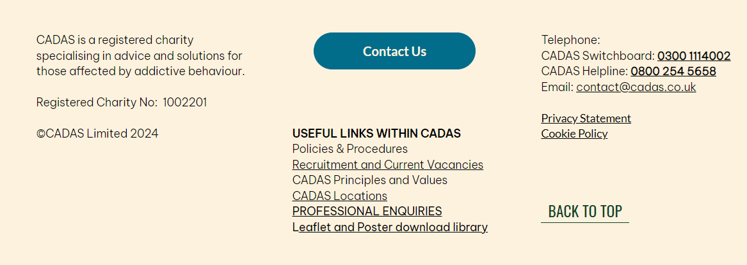

Applications should be returned via email contact shown on the bottom of the application form by 5.00pm Friday 6th June 2025.
The shortlisting and interview process:
Successful applicants will be invited to an interview at one of our offices – date to be confirmed.
If you are interested in the post and feel you have the skills but would like to discuss it, please get in touch with Gail Jenson on either gailj@cadas.co.uk or call on 07493 865637.

